**IPV Assignment 4 (week 4)**

**Goal: Morphological operations and applications**

**Q1:** Dilation and Erosion (do them during the lesson)

Create your own matlab live scripts to implement the following dilation and erosion examples in matlab.

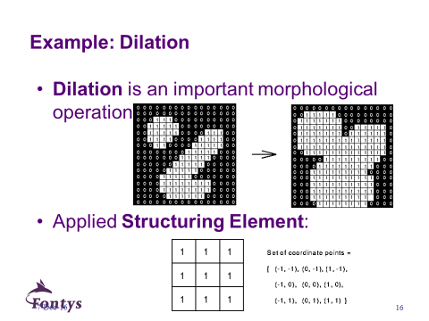

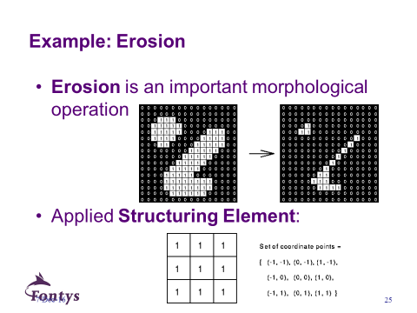

**Q2:** see the slide below

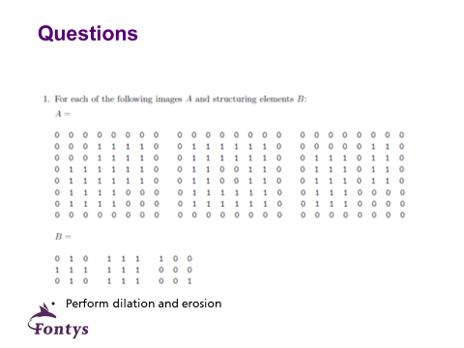

☞ <ftp://qiftp.tudelft.nl/DIPimage/docs/Introduction_to_DIPimage.pdf> Finish the following parts:

* the part 7 binary morphology

**Q3:** write down all the commands you used in perform **the part 7 binary morphology**

in your .mlx file

**Q4:** Goal: Make your own demo for binary morphology.

Must have:

* choose your own images
* explain how/why you design **SE(Structuring Element)/mask/kernel**
* show the comparison of the original image and processed images to demonstrate the applications (see below)

Requirements:

* you need to use morphological operations(erosion, dilation, opening and closing)
* **you can choose at least 3 applications**: Applications: segmentation, edge detection, image contour extraction, handwritten digits and contrast-enhancement

**Q5:** Goal: implement in matlab to identify features based on shape. (you can choose your own images as well)

|  |  |  |
| --- | --- | --- |
| Examples_1 |  | |
|  | input | output |
| Examples_2 | http://www.dai.ed.ac.uk/HIPR2/images/art4.gif | http://www.dai.ed.ac.uk/HIPR2/images/art4clo1.gif |
| Examples_3 | http://www.dai.ed.ac.uk/HIPR2/images/art3.gif | http://www.dai.ed.ac.uk/HIPR2/images/art3opn1.gif |

**Q6:** Goal: implement in matlab for [**Morphological image Reconstruction**](https://nl.mathworks.com/help/images/ref/imreconstruct.html)(you can choose your own images as well)

